A2026-Eur- Germany, Swabia, Vogelherd cave, Lonetal, figurine-**mammoth-ivory-**35,000 BP

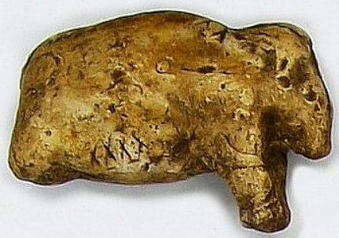

**Formal Label:** Germany, Swabia, Vogelherd cave, Lonetal, figurine-**mammoth-ivory-**31,000 BP

**Case Description:**

**The artist who sculpted this mammoth which was excavated in 2007 (**Spiegel Online 2007) **is in a semi-reclining pose as of one getting up from a resting position, an ideal time to strike for a hunter. This carving of a mammoth is schematic and has zones marked with “x’s” that have been incised to indicate where hunters should place their projectile points.**

**Accession Number:**

#### ****LC Classification:**** GN772.2.A8

**Date or Time Horizon:** 35,000 BP

**Geographical Area:** Vogelherd cave, Lonetal, Swabia, Germany

**Map, GPS Coordinates:** [48°33′31″N 10°11′39″E](https://tools.wmflabs.org/geohack/geohack.php?pagename=Vogelherd_Cave&params=48_33_31_N_10_11_39_E_type:landmark)

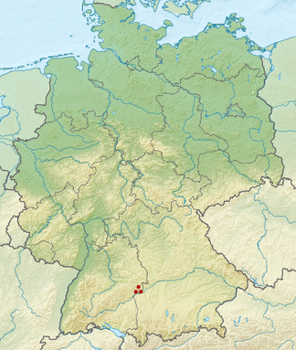

Fig. Map of Vogelherd cave in Germany.

**Cultural Affiliation:** Aurignacian

**Medium:** mammoth ivory.

**Dimensions: original, L 3.7 cm  
Weight: original 5.7 gm**

**Provenance: excavated by the University of Tübingen in 2007.**

**Condition:** replica of original.

**Discussion:** Vogelherd cave figurines, which were first discovered in 193,1 are attributed to early modern *Homo sapiens* of the Aurignacian culture. Miniature sculptures of mammoth ivory dating to 35,000 BP are among the oldest figurines in the world. This limestone karst cave was formed as water percolated through the limestone and hollowed out massive tunnels totaling 170 m2 (1,800 sq ft). The occupation of the cave was first by Neanderthals and then early modern Homo sapiens (Niven 2006). Its location on a hill 20 m (66 ft) above the river Lone has a 180o view of the valley, which was perfect for hunters of Pleistocene game like mammoths, reindeer, aurochs and tarpans.

The **schematic zones marked with “x’s” that have been incised on this mammoth figurine indicate the targets where hunters should place their projectile points**:

**3 x’s on the left rear flank, intestines, foetus**

**4 x’s on the right rear flank, intestines, foetus**

**4 x’s on the lower belly on both sides, intestines**

**3 x’s on the right shoulder, lungs**

**10 x’s on the left shoulder, lungs.**

**Since hunters normally sought out pregnant cows, the rear flank is location of the fetus in a cow and probably a sure kill spot. The shoulder zones may indicate the lung area which is usually a sure kill spot. The lower belly area with the intestines as a target may also be a kill spot, but it is not certain.**

**References:**

# Niven, Laura. 2006. *The Palaeolithic occupation of Vogelherd Cave: implications for the subsistence behavior of late Neanderthals and early modern humans*. Tübingen publications in prehistory. Tübingen: Kerns.

## Spiegel Online. 2007.Ice Age Art 35,000-Year-Old Mammoth Sculpture Found in Germany. http://www.spiegel.de/international/zeitgeist/ice-age-art-35-000-year-old-mammoth-sculpture-found-in-germany-a-489776.html